|  |  |  |  |  |  |  |  |  |
| --- | --- | --- | --- | --- | --- | --- | --- | --- |
|  |  |  |  | **Year 11 Integrated Science** | | |  |  |
|  |  |  |  | **Task 1** | | |  |  |
|  |  |  |  | **Investigating Stomata** | | |  |  |
|  |  |  |  |  |  |  |  |  |
|  |  |  |  |  |  |  |  |  |
| **Name:** | | **Teacher:** |  | **Score:** | **/30** | | |  |
| **Date:** | |  |  |  |  |  |  | | |  |

Introduction:

Stomata (singular: stoma) are responsible for allowing gas exchange between the inside of the leaf and the atmosphere. When viewed with a microscope, they often look like coffee beans.

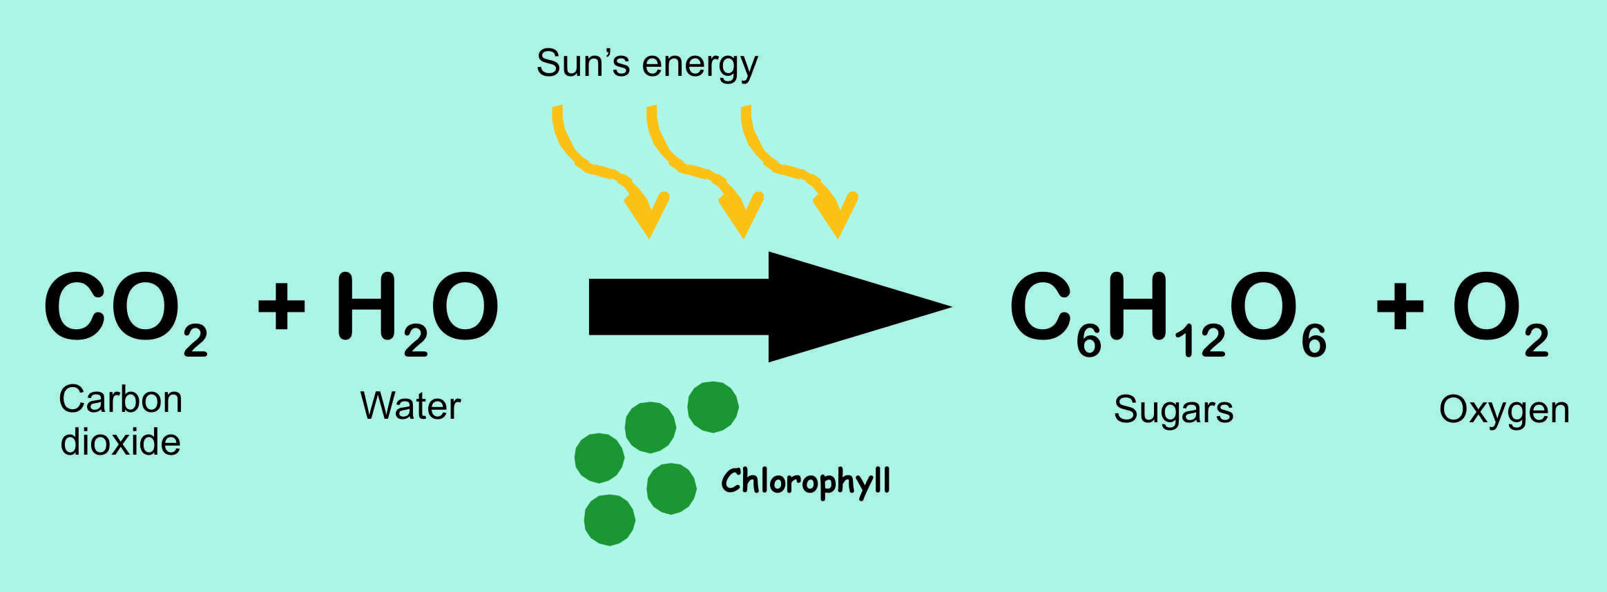Carbon dioxide (CO₂), oxygen (O₂) and water (H₂O) commonly move in or out via the stomata.

This gas exchange is important for plants to produce their own food through photosynthesis.

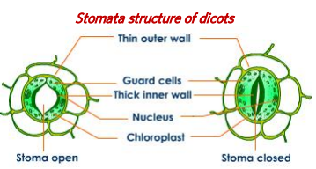Each stoma is made of two *guard cells*. When these guard cells are swollen with water, they create an opening between them, the stomatal pore. Gas exchange occurs via the pore. When the guard cells are flaccid they lay close together, thus closing the stomatal pore.

In addition to opening and closing the stomata, plants may exert control over their gas exchange rates by varying stomata density in new leaves when they are   
produced (such as in the spring or summer).   
The number of stomata per unit area is a   
measurement of *stomata density*.

Why might it be adaptive for a plant to control its rates of water loss and CO2 uptake?

One answer can be found in the sun.  Increases in heat could denature proteins of membranes of chloroplasts.  When overheated, plants may open the stomata to evaporate water to lower the temperature.   Based on this, you could hypothesize that leaves in the sun would have a higher stomatal density than leaves in the shade.

On the other hand, if water is not available, such as under drought conditions, excessive evaporation might lead to desiccation (drying out.)  Plants in hot areas may benefit from fewer stomata so that they can conserve water.

For this investigation, you will be given a leaf from fully grown *Eucalyptus spp.* Your aim is to investigate how the density (# stomata/mm2) varies between the top and underside of the leaf.

1. Identify the variables from the investigation (3 marks)

Independent variable:

Dependent variable:

Controlled variables:

1. Write a hypothesis for this investigation: (2 marks)

The method for making the two necessary microscope slides has been outlined for you below:

1. Obtain leaf and identify the top and underside
2. Make observations about the appearance (similarities and differences) between the two sides of the leaf.
3. Paint a thin (5 mm) strip of clear nail polish on the leaf between two parallel veins and allow to dry.
4. Place a piece of clear tape over the nail polish and gently but firmly press the tape onto the leaf.
5. Peel the tape off the leaf and re-stick it onto a microscope slide. Label as either top/underside
6. Repeat step iii) through v) for the other side of the leaf.
7. View each of the slides at 100x magnification and fill in the information below

Observations and Calculations:

Microscope: (7 marks)

Field of view diameter: ________ mm

Field of view radius: _______ mm

Field of view area (π*r2): ______ mm2

Top side of leaf:

Number of stomata in field of view (400x): __________

Calculate the density of stomata in 1mm2: __________ /mm2

Underside of leaf:

Number of stomata in field of view (400x): __________

Calculate the density of stomata in 1mm2: __________ /mm2

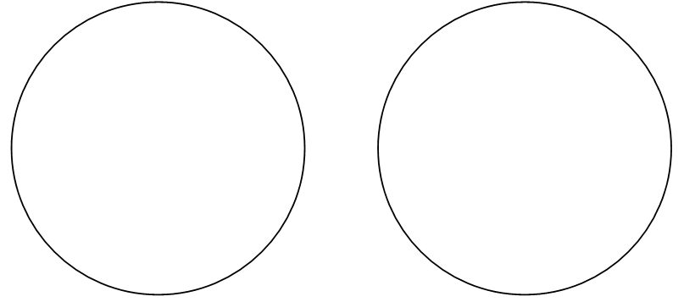Draw scientific diagrams of the two slides you observed (6 marks)

Title: ______________________________ Title: ______________________________

Magnification: ­­­­______________________ Magnification: ­­­­______________________

Create an appropriate graph using the data you have collected (5 marks)



Write a discussion which attempts to answer the question/aim of the investigation.

Remember to include:

A statement which references your hypothesis and whether it was correct or not. (2 mark)

Use data that you have collected/calculated to state the final result of the investigation. (3 marks)

Attempt to explain the result you have discovered using your background knowledge. (2 marks)

__________________________________________________________________________________

__________________________________________________________________________________

__________________________________________________________________________________

__________________________________________________________________________________

__________________________________________________________________________________

__________________________________________________________________________________

__________________________________________________________________________________

__________________________________________________________________________________

__________________________________________________________________________________

__________________________________________________________________________________

__________________________________________________________________________________

__________________________________________________________________________________

__________________________________________________________________________________

__________________________________________________________________________________

__________________________________________________________________________________

__________________________________________________________________________________

__________________________________________________________________________________

__________________________________________________________________________________

__________________________________________________________________________________

__________________________________________________________________________________

__________________________________________________________________________________

__________________________________________________________________________________

__________________________________________________________________________________

__________________________________________________________________________________

__________________________________________________________________________________

__________________________________________________________________________________